**Using a Graphite Cathode as an Electron Donor in Anammox Electrolysis Cell to Investigate Extracellular Electron Transfer**

**Abstract**

Researchers have examined the variation of growth and activity of Anammox with different inorganic or organic electron donors. However, the need for the addition of chemical electron donors could be assuaged by supplying electrons directly via current. Extracellular electron transfer (EET) through cellular electron carriers, notably c-type cytochrome, is used for transfer of electrons between cells and toward the surrounding environment. Specifically, extracellular c-type cytochrome could allow the Anammox cell to utilize the electric current supplied by electrodes in cellular metabolic processes. Furthermore, Electrodes supplying a low dose current has been demonstrated to increase the metabolic activity of microbial activity in other anaerobic and aerobic bacteria. In this study, I will apply a series of different currents to an Anammox bioreactor to achieve two purposes: 1) To investigate if adding current to Anammox bacteria could increase the metabolic activity and thus the nitrogen removal rate and 2) If it does increase the metabolic rate, what is the optimal current for their growth?

**Background and Justification:**

Anaerobic Ammonia Oxidizing (Anammox) bacteria are able to oxidize ammonia to nitrogen gas using nitrite as an electron acceptor. Extensive research has been conducted to accelerate the growth of Anammox colonies to maximize their ability to execute the complete anoxic oxidation of ammonia to dinitrogen under low organic carbon conditions (Waki, Yasuda, Fukumoto, Kuroda, & Suzuki, 2013). This unique ability obviates the need for bioreactor sludge aeration and influent organic carbon streams. It makes Anammox a nascent endeavor in the field of wastewater remediation. Yet, despite its advantages, the principal weakness of the Anammox cell lies in its slow growth rate. It has a doubling time of 7-22 days and thus requires a long start-up time to establish a bioreactor (Waki et al., 2013).

Extracellular electron transport is attributed to extracellular membrane electron carriers such as quinones (notably or anthraquinone-2,6-disulfonate (AQDS)), phenazines, flavins (Kotloski & Gralnick, 2013) and heme proteins (notably c-type cytochrome(Rosenbaum, Aulenta, Villano, & Angenent, 2011)). Furthermore, these surface electron carriers facilitate the transport of electrons on the surface of the cell to the internal metabolic processes within the cell(Thrash & Coates, 2008). The examination of the structure of the Anammox extracellular matrix reveals an abundance of c-type cytochrome. These form the majority of the extracellular complex, manifesting in the vermillion color of the Anammox aggregate(Kartal et al., 2011). C-type cytochrome, an electron transport protein in the electron transport chain has been previously demonstrated to be a feasible extracellular electron carrier in geobacter, desulfovibrio, and various other denitrifiers(Thrash & Coates, 2008). Previous studies involving extracellular electron transport via electrodes to biofilm bacteria revealed an increase in population growth and cellular metabolites, which is correlated with discrete current measurements spanning from 10-100mA ([Thrash & Coates, 2008](l%20)).

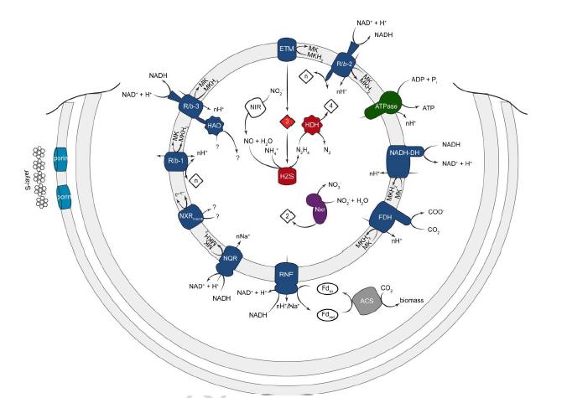

Figure 1: The proposed mechanism for Anammox process inside the Anammoxosome (de Almeida et al., 2016).

According to figure 1 (de Almeida, Wessels et al. 2016),c-type cytochrome redox is strongly correlated with hydrazine dehydrogenase and hydrazine synthase. Thus, we can expect to see proliferation of the two enzymes. Figure 1 illustrates that the c-type cytochrome uptakes electrons to donate hydrazine synthase and accepts electrons from hydrazine dehydrogenase. It may be presumed that the addition of electrons to c-type cytochrome will result in a negative charge accumulation in the Anammoxosome lumen and result in a stronger proton-motive force to generate more ATP.

A study in 2016 tested the effects of an external electric field on an Anammox inoculated bioreactor. The conclusions revealed an enhanced the Anammox nitrogen removal rate. More so, it increased Anammox constituency in bioreactors compared to those that didn’t have the electric field (Yin, Qiao, & Zhou, 2015). These results imply that efforts to enhance the electrical environment of the Anammox bioreactor does affect the performance of Anammox.

The goal of this study is to accelerate the establishment of a stable community in an Anammox bioreactor. The stable community will be determined by an increase in ammonia and nitrite removal rate (NRR). If electrical current will increase the activity of the Anammox cells during startup, this could be a factor in hastening the languid establishment of an Anammox community in a bioreactor.

**Methods:**

Electrodes:

Graphite electrodes wrapped in graphite mesh provides an uneven surface with high surface area for the cultivation of biofilm. It has been used to deliver electrons to various different types of denitrifying bacteria in both bioreactor and batch processes (Thrash & Coates, 2008).

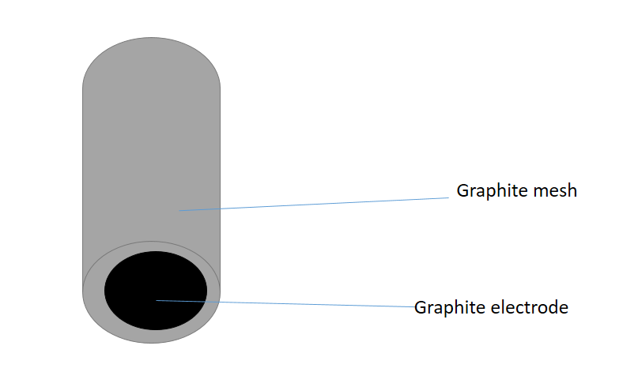

Figure 2: The cathode will be a graphite electrode wrapped in a graphite mesh. The graphite mesh will provide increased surface area for biofilm and aggregate attachment.

Cultivation of electrode surface with biofilm:

In order to create a steady-state environment for Anammox biofilm growth on the electrodes, we will first start up a steady-state bioreactor. A peristaltic pump will provide a constant influent and effluent flow of growth medium to maintain the medium at 100mg/L NH­4+ and NO2-, 0.42g HCO3-‑­/L and trace elements levels (Van de Graaf, de Bruijn, Robertson, Jetten, & Kuenen, 1996). After placing five graphite electrodes into the bioreactor (see figure 2), we will then inoculate the bioreactor with Anammox bacteria. The bioreactor will be a CSTR with a minimal stirring rate of 100-200 rpm to maintain medium homogeneity without agitating biofilm growth. Since the principal removal of ammonia is by Anammox, the ammonia and nitrite removal rate will determine if the Anammox population has stabilized. Ammonia removal rate will be tested in the effluent via HACH test(Model NI-8; Hach Chemical Co., Loveland, CO, USEPA approved method #8038) Measurements for ammonia and nitrite level will be taken once a day. Once the measurement normalized standard deviation for 3 days reaches a tolerance of .10, then the Anammox community would have been assumed to have reached steady state. After that we can transport each of the respective cathodes to an electrolysis cell.

In a steady state bioreactor, the parameters of all the electrodes will be identical. Thus, before the extraction of the working electrodes for insertion into the electrolysis cell, a non-working (but identical) electrode will be scraped of biofilm. The biofilm properties and constituents can be analyzed via confocal laser scanning microscopy and 16s ribosomal RNA analysis, respectively (R. J. Palmer, Haagensen, Neu, & Sternberg, 2006; Robert J Palmer & Sternberg, 1999).

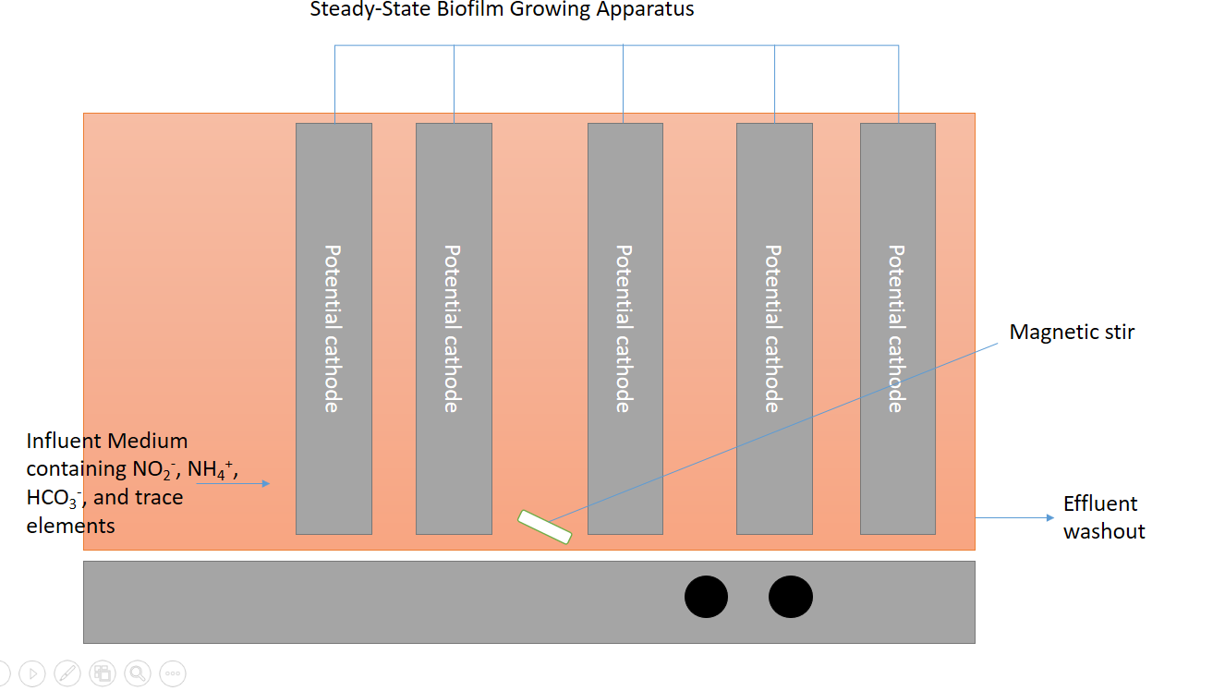

Figure 3: The bioreactor for growing Anammox biofilm on the surface of the electrodes. This bioreactor will be stirred stirred at 100 rpm

The electrolysis cell:

There will be 4 total fuel cells at currents of 10, 20, 30, 40 mA. The penultimate goal is to realize an optimized current for the Anammox growth. See figure 3 for reference to electrolysis cell design. The anode will be a sterilized graphite electrode. The graphite electrode will be sterile to ensure that there aren’t existing bacteria on it that will affect our Anammox community constituency. To maintain steady state, an influent and effluent stream will be installed. More so, a peristaltic pump will maintain the influent and effluent rate such that the electrolysis cell’s liquid and constituent concentration level is constant. An influent stream will provide the Anammox with fresh medium while an effluent will take the spent medium to a waste container. To maintain pH 7.0 and a temperature of 37 $°C$, a pH/temperature probe will be put into the cathode chamber. To maintain anoxic conditions, both the chambers, as well as the influent and effluent stream sources will be flushed with 100% dinitrogen gas.

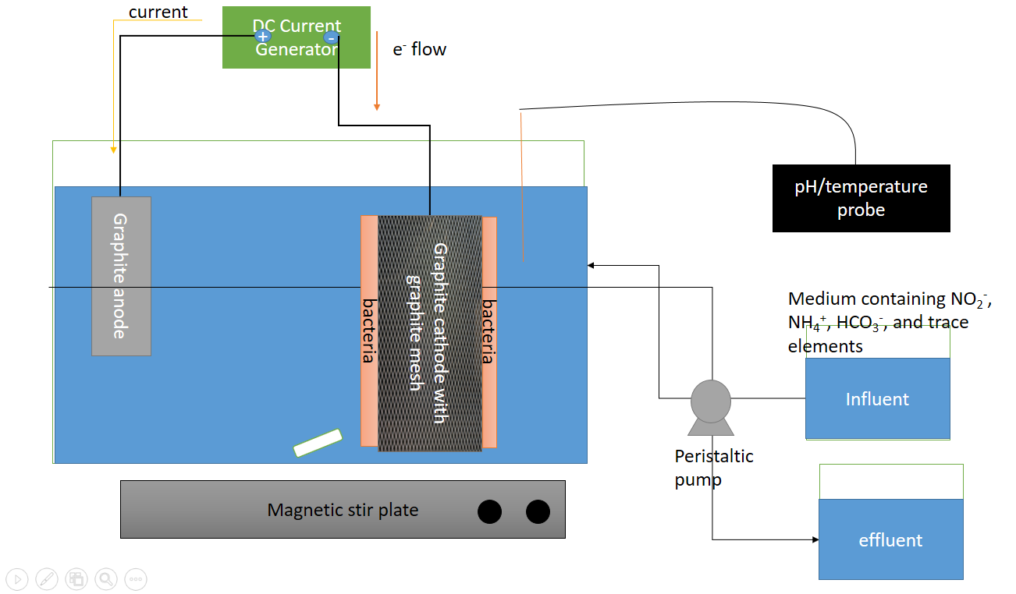

Figure 4: Electrolysis Cell design with containing the graphite electrodes.

Attachment of electrode to electrolysis cell:

Once the electrode surfaces have accumulated biofilm and the NRR has stabilized, a small portion of biofilm on each electrode surface can be analyzed via hydrazine dehydrogenase activity level. Since Anammox Because the activity of hydrazine dehydrogenase is correlated with changes in the absorbances of c-type cytochrome, we can detect differences in the Anammox activity by performing spectroscopic analyses of the c-type cytochrome(Shimamura et al., 2007). The electrode will then be transferred to an electrolysis cell set-up (see figure 2). The constructed fuel cell will be continuously stirred at 100-200 rpm to maintain medium homogeneity.

Testing for increased activity in response to current and bacterial flora change in response to current:

The ammonia removal rate will be measured 3 times a day via HACH test (Model NI-8; Hach Chemical Co., Loveland, CO, USEPA approved method #8038) throughout the whole electrolysis cell experiment. Once in the fuel cell, the current (10, 20, 30, or 40 mA, respectively) will be supplied for two days with two days of rest. The rest period is to determine whether the increase in activity is due to the increase in current. An increase in activity in response to the current will be prevalent if the activity level stagnates with a loss of current. At the end of this process, the biofilm flora will be analyzed via confocal microscopy and scraped off the surface for 16s rRNA gene sequencing and evaluated for changes in composition.

No current control test:

A negative control will be initiated as well. Another biofilm coated electrode will be inserted into a fuel cell setup with no current applied. The construct of this negative control must be identical minus the current since we must extirpate any other extraneous factors that could change the growth rate in the fuel cell. Since the NH4+ and NO2- concentrations are the most real-time indicator of Anammox activity, the NH4+ and NO2- without current will be measured to observe how they change in the medium without the presence of bacteria.

Abiotic control test:

Abiotic test will be performed with the electrolysis cell to evaluate the changes in NH4+, NO2- and pH at the cathode and anode. The medium will be without bacteria. Experiments will be conducted using an increasing 10,20,30,40 mA current without rest-time. Ideally, the addition of the bicarbonate buffer will resist changes in pH.

Analyzing effects of current on biofilm

After the current application is finished, the electrolysis cell will be shut off and biofilm on the electrode will be scraped off and analyzed via 16s rRNA analysis and confocal microscopy. These results will be contrasted with the initial constituency and biofilm properties.

References

de Almeida, N. M., Wessels, H. J., de Graaf, R. M., Ferousi, C., Jetten, M. S., Keltjens, J. T., & Kartal, B. (2016). Membrane-bound electron transport systems of an anammox bacterium: A complexome analysis. *Biochim Biophys Acta*. doi:10.1016/j.bbabio.2016.07.006

Kartal, B., Maalcke, W. J., de Almeida, N. M., Cirpus, I., Gloerich, J., Geerts, W., . . . Strous, M. (2011). Molecular mechanism of anaerobic ammonium oxidation. *Nature, 479*(7371), 127-130. doi:10.1038/nature10453

Kotloski, N. J., & Gralnick, J. A. (2013). Flavin Electron Shuttles Dominate Extracellular Electron Transfer by Shewanella oneidensis. *MBio, 4*(1). doi:10.1128/mBio.00553-12

Palmer, R. J., Haagensen, J. A. J., Neu, T. R., & Sternberg, C. (2006). Confocal Microscopy of Biofilms — Spatiotemporal Approaches. In B. J. Pawley (Ed.), *Handbook Of Biological Confocal Microscopy* (pp. 870-888). Boston, MA: Springer US.

Palmer, R. J., & Sternberg, C. (1999). Modern microscopy in biofilm research: confocal microscopy and other approaches. *Current opinion in Biotechnology, 10*(3), 263-268.

Rosenbaum, M., Aulenta, F., Villano, M., & Angenent, L. T. (2011). Cathodes as electron donors for microbial metabolism: which extracellular electron transfer mechanisms are involved? *Bioresour Technol, 102*(1), 324-333. doi:10.1016/j.biortech.2010.07.008

Shimamura, M., Nishiyama, T., Shigetomo, H., Toyomoto, T., Kawahara, Y., Furukawa, K., & Fujii, T. (2007). Isolation of a multiheme protein with features of a hydrazine-oxidizing enzyme from an anaerobic ammonium-oxidizing enrichment culture. *Appl Environ Microbiol, 73*(4), 1065-1072. doi:10.1128/AEM.01978-06

Thrash, J. C., & Coates, J. D. (2008). Review: Direct and Indirect Electrical Stimulation of Microbial Metabolism. *Environmental Science & Technology, 42*(11), 3921-3931. doi:10.1021/es702668w

Van de Graaf, A. A., de Bruijn, P., Robertson, L. A., Jetten, M. S., & Kuenen, J. G. (1996). Autotrophic growth of anaerobic ammonium-oxidizing micro-organisms in a fluidized bed reactor. *Microbiology, 142*(8), 2187-2196.

Waki, M., Yasuda, T., Fukumoto, Y., Kuroda, K., & Suzuki, K. (2013). Effect of electron donors on anammox coupling with nitrate reduction for removing nitrogen from nitrate and ammonium. *Bioresource Technology, 130*, 592-598. doi:<http://dx.doi.org/10.1016/j.biortech.2012.12.101>